THEORETICAL COMPETITION

**February 16, 2022**

**Please read this first:**

1. The duration of the theoretical competition is 4 hours. There are three problems.
2. You can use your own calculator for numerical calculations.
3. You are provided with ***Writing sheet*** and additional white sheets of paper. You can use the additional sheets of paper for drafts of your solutions, but these sheets will not be graded. Your final solutions should be written on the ***Writing sheets***. Please use as little text as possible. You should mostly use equations, numbers, figures, and plots.
4. Use only the front side of ***Writing sheets*.** Write only inside the boxed areas.
5. Start putting down your solution to each problem on a new ***Writing sheet***.
6. Fill in the boxes at the top of each ***Writing sheet*** with your country (**Country),** your student code (**Student Code**), problem number (**Question Number)**, the progressive number of each ***Writing sheet*** **(Page Number**), and the total number of ***Writing sheets*** used (**Total Number of Pages**). If you use some blank ***Writing sheets*** for notes that you do not wish to be graded, put a large X across the entire sheet and do not include it in your numbering.

**Problem 1 (10.0 points)**

This problem consists of three independent parts.

**Problem 1.1 (4.0 points)**

A ball of radius $R$ rests on the edge of a horizontal table of height $h=3R$. The ball starts to fall without a significant initial push, and there is no slipping with the edge during the entire time of motion. Find at what distance $l$ from the base of the table the ball first touches the floor. The free fall acceleration is equal to $g$, air resistance is negligible. It is known that the kinetic energy of a ball rolling without slipping is equal to $E=\frac{7}{10}mv^{2}$, where $v$ denotes the speed of the ball center with $m$ being its mass.

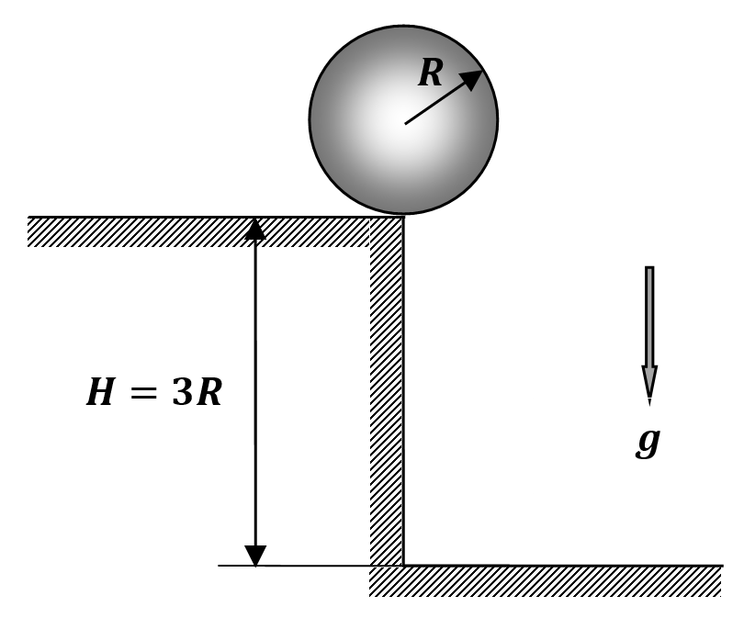

**Problem 1.2 (3.0 points)**

A quasi-static process is carried out with one mole of an ideal monatomic gas, as a result of which its initial volume $V_{0}=1 m^{3}$ increases four times, and the initial pressure $p_{0}={10}^{5}$ Pa decreases two times. It is known that for each small section of the quasi-static process, the ratio of work to the change in internal energy is a constant value. Find the total work $A$ done by the gas in this process.

**Problem 1.3 (3.0 points)**

A thin-walled dielectric hemisphere, negatively charged with the surface density $–σ$, is placed on the horizontal table. A point-like ball of mass $m$ is carefully placed on its top. Determine the minimum positive charge $Q$ of the ball, such that it is still in a state of stable equilibrium at the top of the hemisphere. The charges between the hemisphere and the ball are not redistributed. The free fall acceleration is $g$.

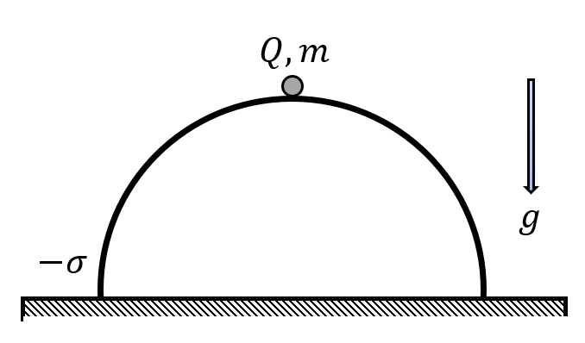

**Problem 2. Greenhouse effect (10.0 points)**

**Introduction**

Any heated body, whose temperature $T$ is above absolute zero, radiates electromagnetic waves. The spectrum of this radiation, called thermal, depends on the optical properties of the body surface and its temperature. Despite the fact that the radiation of each body is its individual characteristic, general laws are well known that describe the thermal radiation.

Kirchhoff's law. In a state of thermodynamic equilibrium, the ratio of the emissivity of a body $r(λ,T)$ to its absorptivity $k(λ,T)$ is a universal function $r_{0}(λ,T)$ that does not depend on individual characteristics

$\frac{r(λ,T)}{k(λ,T)}=r_{0}(λ,T)$.

The value $r(λ,T)Δλ$ has the meaning of the energy emitted per unit area per unit time in a narrow wavelength range from $λ$ to $λ+Δλ$. The absorptivity of the body $k(λ,T)$ is a dimensionless absorption coefficient equal to the ratio of the radiation energy absorbed by the body to the total radiation energy incident on the body surface, if the wavelengths of the incident radiation lie in a narrow wavelength range from $λ$ to $λ+Δλ$. If the body completely absorbs all the incident electromagnetic radiation $k\left(λ,T\right)=1$, then such a body is called an absolute black body.

Wien's displacement law. The wavelength $λ_{max}$,, at which the function r $r_{0}(λ,T)$ has a maximum, is related to the absolute temperature by the relation

$λ_{max}T=b$*,*

where $b=2.898∙{10}^{-3}$ m/K is called the Wien constant.

Stefan-Boltzmann law. The total emissivity of a black body over all wavelengths is described by the formula

$R\left(T\right)=\int_{0}^{∞}{}r_{0}(λ,T)dλ=σT^{4}$,

where $σ=5.670∙{10}^{-8} W/(m^{2}∙K^{4})$ stands for the Stefan-Boltzmann constant.

Using the Stefan-Boltzmann law, the formula for $r_{0}(λ,T)$ can be represented as

$r_{0}\left(λ,T\right)=σT^{4}φ\left(λ,T\right)$.

Here, the Planck function $φ\left(λ,T\right)$ describes the energy distribution in the black body radiation spectrum; the value $φ\left(λ,T\right)Δλ$ is equal to the fraction of the thermal radiation energy per narrow spectral interval from $λ$ to $λ+Δλ$. The total area under the graph of the function $φ\left(λ,T\right)$ is equal to unity. In this problem, it is recommended to use the graphs of this function, shown in the figure below and plotted at temperatures $t=0℃$ and $t=50℃$.

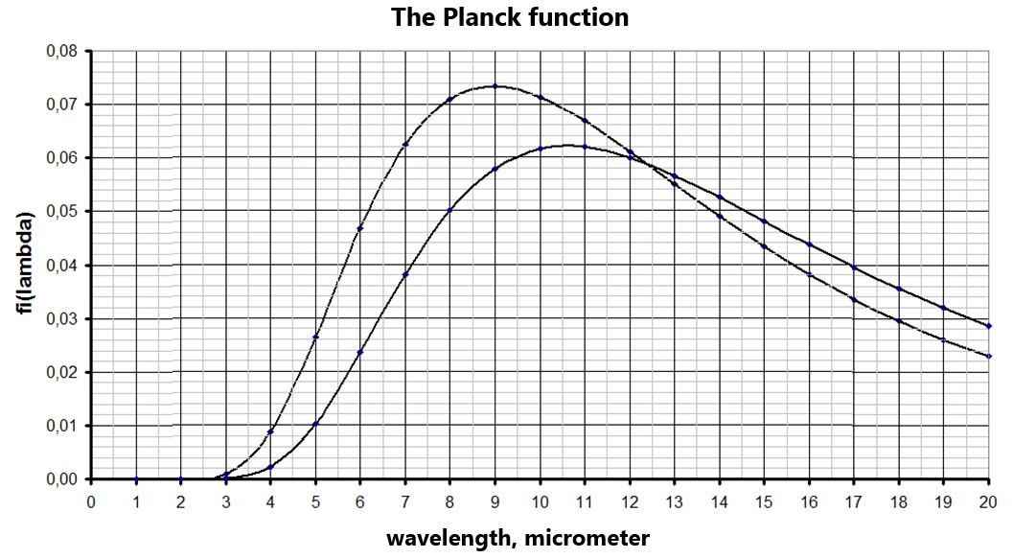

**Model of the Earth and its atmosphere**

Climate change associated with an increase in the average temperature of the atmosphere is now an established scientific fact. It is believed that the main cause of the global warming is the greenhouse effect. Solar radiation, whose main part lies in the visible region of the spectrum, passes almost completely through the atmosphere, and then is absorbed by the earth's surface. On the contrary, the thermal radiation of the earth's surface, which lies mainly in the infrared region of the spectrum, is significantly absorbed by certain atmospheric gases, mainly water vapor and carbon dioxide. In this problem, the simplest model of the greenhouse effect is considered and some numerical estimates are made of its influence on the atmospheric temperature.

The surface of the Earth is assumed to be an absolutely black body of a spherical shape, covered with a layer of the atmosphere, whose thickness is much less than the Earth radius. Conventionally, the atmosphere is divided into two parts: 1) the lower layer, directly adjacent to the earth's surface and having the same temperature as the earth’s surface; 2) the upper (greenhouse) layer, capable of absorbing thermal radiation coming from the earth's surface. It is assumed that the transfer of energy between the Sun, the earth's surface and the atmosphere is carried out only through radiation, and the temperatures of the earth's surface and atmospheric layers are the same at all their points and do not depend on time, for example, on the time of day or year season. In the following, the solar constant W/m2 is considered known, which is the power of solar radiation incident on the unit area of the Earth, oriented perpendicular to the incident light.

**Atmosphere without the greenhouse effect**

**2.1** Evaluate the wavelength $λ_{max S}$, which corresponds to the maximum in the thermal radiation of the Sun, if the surface temperature of the Sun is approximately equal to $T_{S}=6500$ K.

**2.2** Neglecting the absorption of the atmosphere and considering the earth's surface as an absolutely black body, evaluate the steady-state temperature of the Earth's surface $T_{0}$, and also determine this temperature $t_{0}$ in the Celsius scale. This temperature is called below as the "black earth" temperature.

**2.3** Calculate the wavelength $λ_{max E}$, which corresponds to the maximum in the radiation of the "black earth".

**2.4** Calculate the power of solar radiation $w$ per unit area of the Earth's surface.

**Various atmosphere models**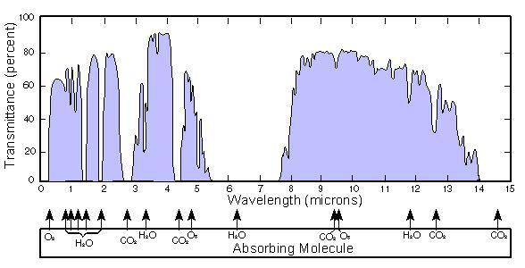

In reality, the upper layer of the atmosphere effectively absorbs electromagnetic radiation of certain wavelengths in the infrared region of the spectrum. For example, the figure on the right shows the real dependence of the atmospheric transmission as a function of the wavelength. As can be seen, this dependence is rather complicated, therefore, in the problem below, several simplified models are considered.

Let $K$ be the total absorption coefficient of the upper layer of the atmosphere for the thermal radiation of the Earth, i.e. the ratio of the energy of the thermal radiation absorbed by the upper layer of the atmosphere to the total energy incident on the upper layer of atmosphere from the earth's surface.

**2.5** Obtain the formula for the steady-state temperature of the Earth's surface $T_{1}$ and express it in terms of the "black earth" temperature $T_{0}$ and the absorption coefficient $K$.

**Maximum greenhouse effect**

Let the upper layer of the atmosphere completely transmit the solar radiation and completely absorb the thermal radiation of the Earth.

**2.6** Calculate how much the temperature of the Earth's surface ${Δt}_{1}=T_{1}-T_{0}$ increases compared to the temperature of the "black earth" due to the maximum greenhouse effect.

**Water greenhouse effect**

Let the spectral absorption coefficient $k(λ)$ of the upper layer of the atmosphere be a known function of the wavelength $λ$ of the incident radiation and be independent of its temperature.

**2.7** Express the total absorption coefficient of the upper atmosphere $K$ in terms of $k(λ)$ and the Planck distribution function $φ(λ,T_{1})$,, where $T_{1}$ denotes the temperature of the Earth's surface.

Assume that the absorption in the upper layer of the atmosphere is completely due to water vapor. Approximately, it can be considered that water vapor completely absorbs radiation whose wavelengths lie in the range from 5.00 to 8.00 μm, whereas the rest is completely transmitted.

**2.8** Using the plots of the Planck distribution function given in the introduction section of this problem, calculate the numerical values of the total absorption coefficient $K$ of the upper atmosphere for two values of the Earth's surface temperatures $t_{1}=0℃$ and $t_{1}=50℃$.

In the above specified temperature range from $t_{1}=0℃$ to $t_{1}=50℃$, the dependence of the total absorption coefficient on the ground temperature $t_{1}$ is approximately described by a linear function of the temperature itself: $K\left(t_{1}\right)=K_{0}(1+αt_{1})$,, where $K_{0},α$ are some constants.

**2.9** Calculate the numerical values of the parameters $K_{0}$ and $α$.

In the following, assume that the temperature changes under question are small, so formulas of approximate calculus can be used.

**2.10** Neglecting the dependence of the absorption coefficient of the atmosphere on the temperature and assuming it to be equal to the absorption coefficient at the temperature of the "black Earth" $T_{0}$, calculate the change in the temperature of the Earth's surface ${Δt}_{1}=T_{1}-T_{0}$.

**2.11** Calculate the change in the temperature of the Earth's surface ${Δt}_{1}=T_{1}-T_{0}≪T_{0}$ if the dependence of the atmospheric absorption coefficient on the temperature is described by the linear function of the earth's temperature as defined above.

**Amplification of the greenhouse effect by carbon dioxide**

Let us take into account the effect of the absorption by carbon dioxide present in the atmosphere. At the current concentration of carbon dioxide in the atmosphere (approximately 0.05%), it can be considered that carbon dioxide completely absorbs the radiation of the Earth in the wavelength ranges from 2.50 to 3.00 µm and from 6.50 to 7.00 µm, and in the range from 16.0 to 18.0 µm the absorption coefficient equals 0.500. For other wavelengths, the absorption of radiation by carbon dioxide can be neglected.

**2.12** Estimate how much, as compared to the water greenhouse effect model, the temperature of the Earth's surface increases due to the absorption of radiation by carbon dioxide.

**2.13** Estimate how much, as compared to 2.12, the temperature of the Earth's surface increases if the concentration of carbon dioxide in the atmosphere increases by $η=2.00$ times as compared to its current concentration.

**Problem 3. Corpuscular interpretation of light pressure (10.0 points)**

**Introduction**

Electromagnetic waves, reflected from the interfaces between media or absorbed by them, exert mechanical pressure, whose corpuscular interpretation is the subject of this problem. The main postulate of the corpuscular theory of electromagnetic radiation states that electromagnetic radiation, in particular light, is a beam of particles called photons with an energy determined by Planck's formula. In what follows, take the speed of light be equal to $c=2.98∙{10}^{8}$ m/s.

**3.1** Let a parallel beam of light with intensity $I_{0}$ fall on a flat surface at an angle $φ$ with the normal, and the coefficient of reflection from the surface is $R=I_{r}/I_{0}$, where $I_{r}$ stands for the intensity of the reflected light. Find the pressure of light $p_{s}$ exerted on the surface, provided that the reflection coefficient does not depend on the angle of incidence.

**3.2** Calculate the pressure $p_{s}$ of the solar radiation, whose intensity is equal to W/m2. Assume that light is incident perpendicular to: (a) the completely absorbing earth's surface; b) the completely reflective (mirror) surface.

**3.3** A ball with the radius $R = 1.00$ m is illuminated by a wide parallel beam of sunlight with intensity W/m2. One half of the ball is made of a material that completely reflects light, while the other half absorbs it completely. Both halves are symmetrically illuminated by the beam. Calculate the moment of light pressure forces acting on the ball about its axis of symmetry, which is perpendicular to the beam and lies in the plane dividing the ball into the mirror and absorbing halves.

**Space station with the mirror sail**

The space station rests far from the planets at a distance of $R_{0}=5.00∙{10}^{7}$ km from the Sun, held by a solar sail (fully reflective mirror) oriented perpendicular to the sun's rays. At certain time moment, the station's engines turn on for a short time and give it an initial speed $V_{0}=9.00$ m/s in the direction from the Sun. Completely ignore the influence of the solar wind, which is a beam of ionized particles, mostly protons, helium nuclei and some others. Consider it known that the Earth moves around the Sun in a circular orbit of the radius $r_{E}=1.50∙{10}^{8}$ km with the speed of $V_{E}=30.0$ km/s.

**3.4** Calculate the maximum distance $R$ from the Sun to the station.

**3.5** Determine the minimum value of the speed $V_{0}=V_{min}$, at which the station will be able to fly away from the Sun

**Poynting-Robertson effect**

In astrophysics, the physical process is well known, such that in the solar system solid dust particles slowly fall onto the Sun along a spiral trajectory whose shape is very close to circular. Let us consider a similar spherical dust particle of radius $a=1.00$ mm and density kg/m3, which rotates around the Sun at such a distance from it that light with intensity W/m2 falls on the dust particle. Under given conditions, the radial component of the pressure of light on the particle can be neglected in comparison with the gravity of the Sun. Consider that dust the particle completely absorbs the incident radiation.

**3.6** Evaluate the characteristic time $τ$, during which the distance to the Sun $R$ decreases by the relative value $μ=\frac{δR}{R}={10}^{-4}$.

**Laser tweezer**

In 2018, the Nobel Prize in physics was awarded to A. Ashkin for the creation of "laser tweezer", a device that allows one to hold and move transparent microscopic objects with the help of light. In one of the devices of such a "laser tweezer", a parallel beam of light from a laser passes through a converging lens $L$ and hits a microparticle $M$, which can also be considered a converging lens. Point $F$ is the common focus of $L$ and $M$ (see figure 3.1 below). The light intensity in the beam is $I=1.00 μW/sm^{2}$, the beam radius is $R=1.00$ cm, the focal length of the lens $L$ is $F=10.0$ cm. Ignore completely the absorption and reflection of light.

**3.7** Calculate the force acting on the microparticle.

To create a force acting on the particle in the transverse direction of the beam, the left half of the lens $L$ is covered by a diaphragm (see figure 3.2 below).

**3.8** Calculate the force acting on the microparticle in the transverse direction of the beam.

|  |  |
| --- | --- |
| Figure 3.1 | Figure 3.2 |

***Mathematical hints for the theoretical problems***

The following formulas may be useful:

$\int{}x^{n}dx=\frac{x^{n+1}}{n+1}+C$*,* where $n≠-1$ is a fixed number*, $C$* refers to an arbitrary constant

$\int{}\frac{dx}{x}=lnln \left|x\right|+C$*,* where $C$ stands foran arbitrary constant

${(1+x)}^{γ}≈1+γx+\frac{γ(γ-1)}{2}x^{2}$*,* for $|x|≪1$ and any value of $γ$

$lnln (1+x) ≈x$*,* for $|x|≪1$